Vicar’s Bible Study

January 7, 2016
The Gospel according to John
Open – Prayer
Sharing
Introduction to John
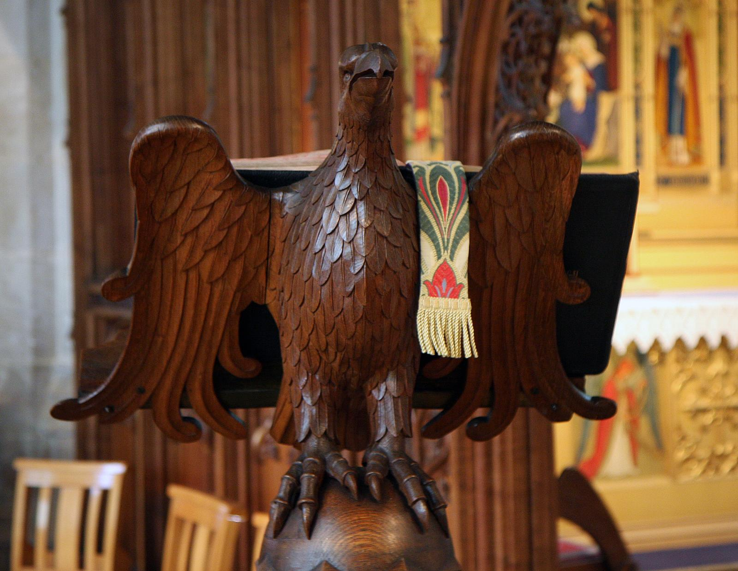
The eagle is often used as a symbol for John’s Gospel. What do you associate with the eagle?
The Four Gospels
Matthew, Mark, and Luke are known as the Synoptic Gospels because they are derived from the same sources and they share many stories in common, either exactly or slightly altered.
The Gospel of John is sometimes known as the Fourth Gospel because it has a distinctive tone and many passages that are not shared by the Synoptic Gospels, or are in a completely different form.
Example: The calling of the twelve disciples in Matthew, Mark and Luke is nearly identical. But the calling of the disciples in John is much longer, has symbolic meaning, and only involves the calling of four disciples. The Synoptic Gospels place the story after their opening stories, but John has the calling of the disciples in chapter one.
See Matthew 10:1-3, Mark 3:13-19, Luke 6:12-16, and John 1:35-51 on separate page.
Date written
Scholars agree that Mark is the earliest gospel, and Matthew and Luke drew much of their material from Mark. All three are dated around 66-90 CE. John, on the other hand, is written 90-110 CE.
Authorship
Read John 21:20-25 This passage claims that the author of the Gospel is “the disciple whom Jesus loved.” References to the “beloved disciple” are found throughout the Gospel of John, and although the Gospel does not identify him, tradition has associated the beloved disciple with the disciple John, son of Zebedee.
Scholars believe there was another John associated with the Church in Ephesus who may have been the John identified as the author. Because the text appears to have been edited by one or several people, scholars believe that the Gospel may have evolved over a period of time. There is good reason to believe that there was a “Johannine Community” with a distinctive character, and it was this community that developed the Gospel over time.
The letters of John and Revelation
1 John, 2 John, and Revelation are traditionally understood to be written by John, and they also may have been products of the Johannine Community.
A Gospel of Conversion
The Gospel of John seems to have been written with conversion of the reader in mind. The Gospel often presents Jesus as a mysterious character who says enigmatic things, and the reader is forced to decide: “Is this Jesus a divine person or not?” Because of this, many people have been converted to belief in Christ through the Gospel of John. Read John 20:30-31.
The Anglican Gospel?
Because the Gospel of John is rich in poetry, symbolism and imagery, it has become a favorite of many Anglicans. Many devotional books have been written on the Gospel of John.
Read John 1:1-18, the Prologue of John
These verses are called the Prologue to John because they are written as a poem. “If John has been described as the pearl of great price among the New Testament writings, then one may say that the Prologue is the pearl within this Gospel… The choice of the eagle as the symbol of John the Evangelist was largely determined by the celestial flights of the opening lines of the Gospel.” Raymond Brown
Read John 1:19-34, the testimony of John the Baptist - There is little in John about the role of John as baptizer or prophet. “The evangelist is only interested in his being a herald of Jesus and his first witness.” Raymond Brown

